1. Write a program to Print Fibonacci Series using recursion.

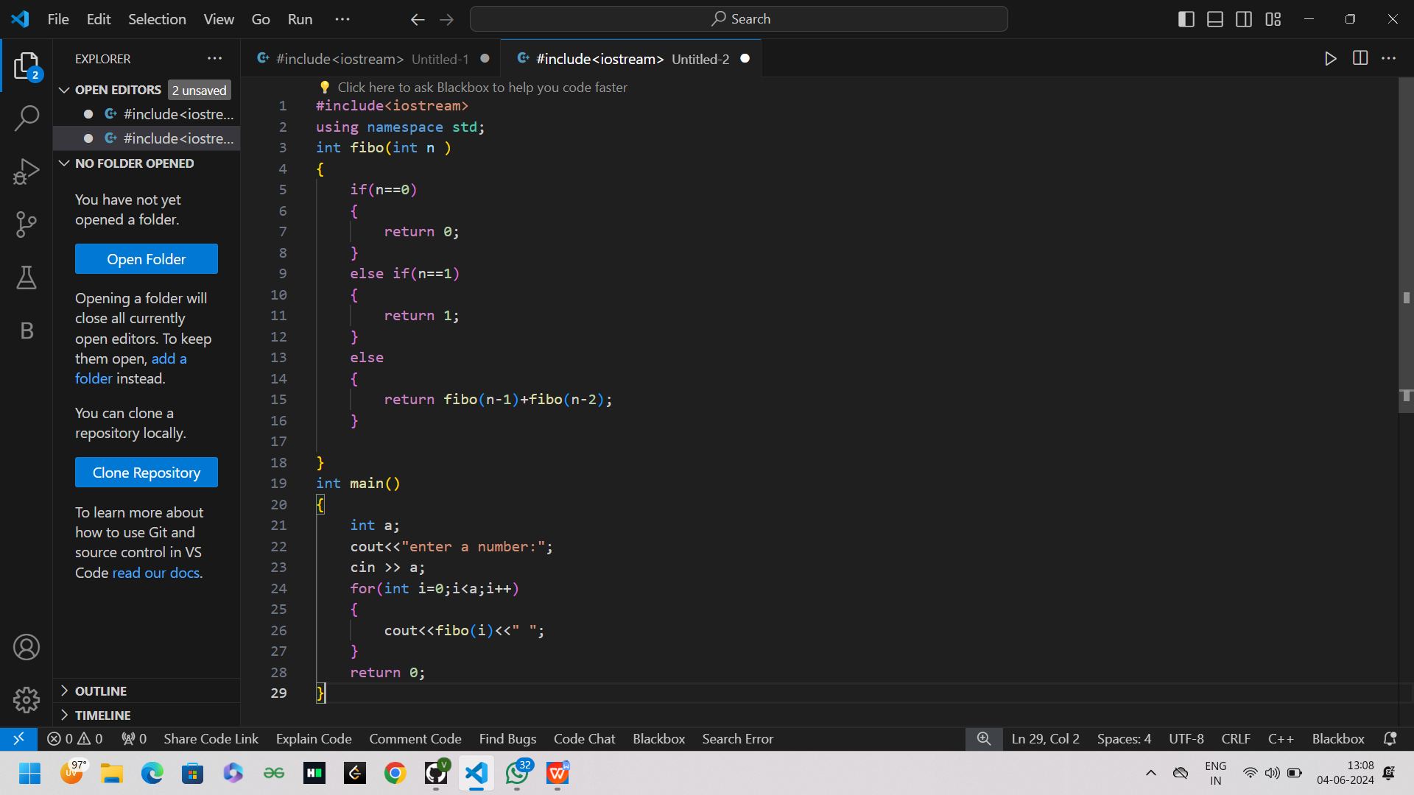

Output:

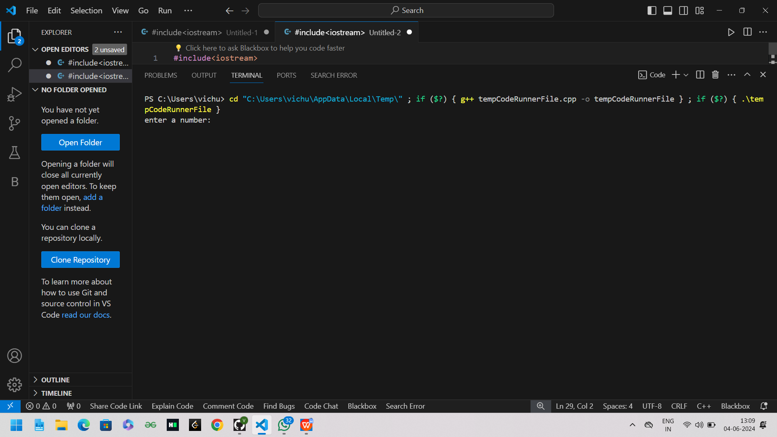

2.Write a program to check the given no is Armstrong or not using recursive function.

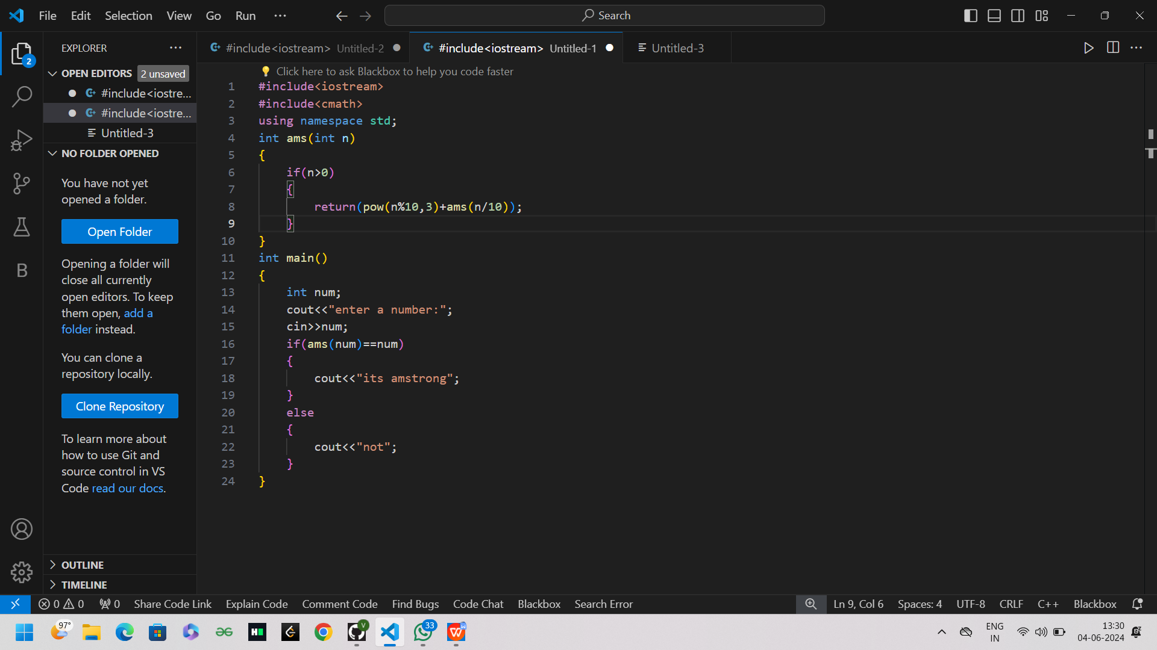

output

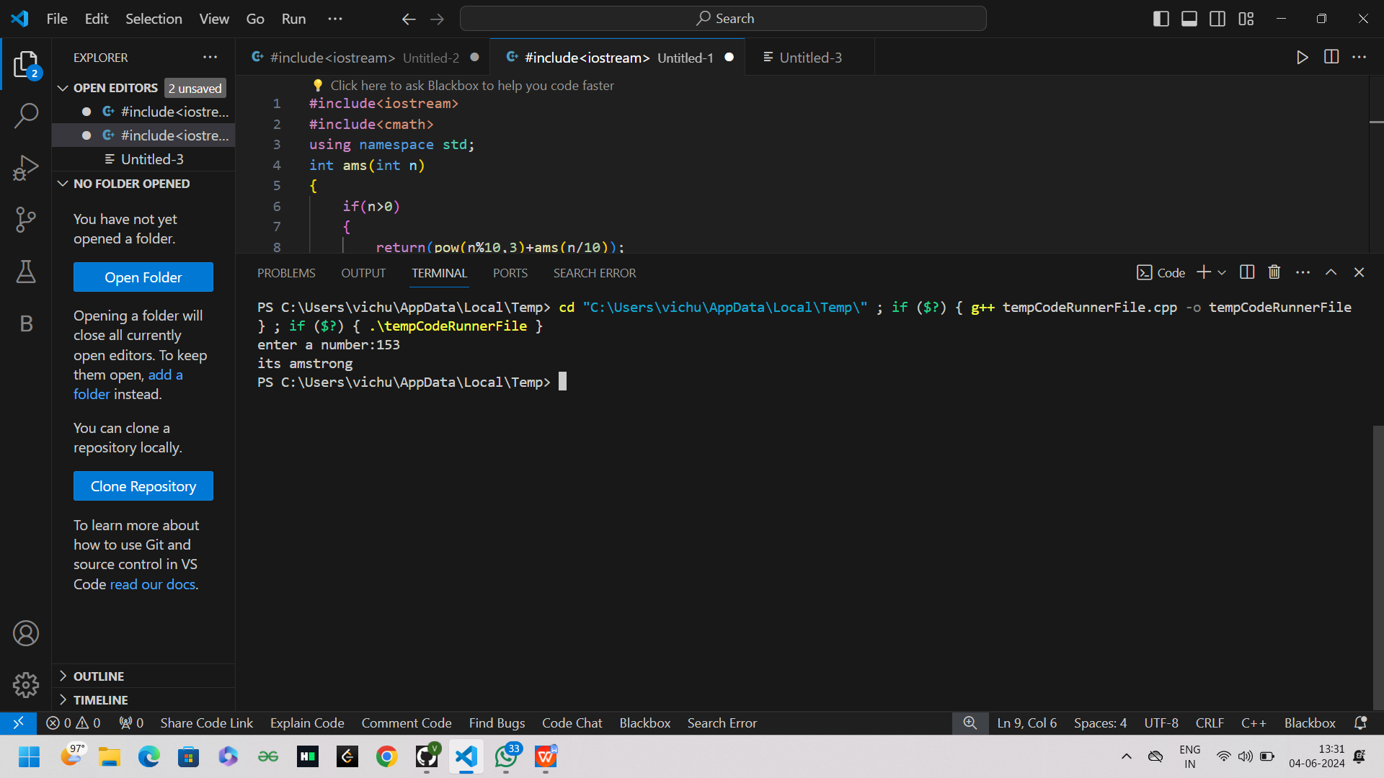

3.Write a program to find the GCD of two numbers using recursive factorization

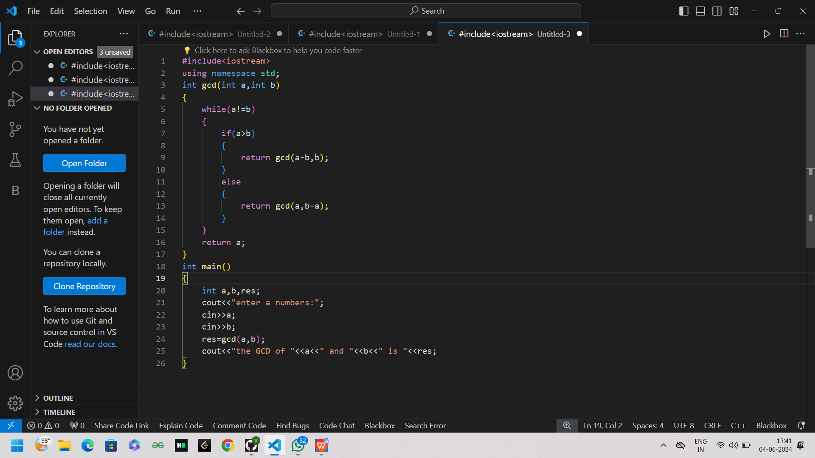

Output

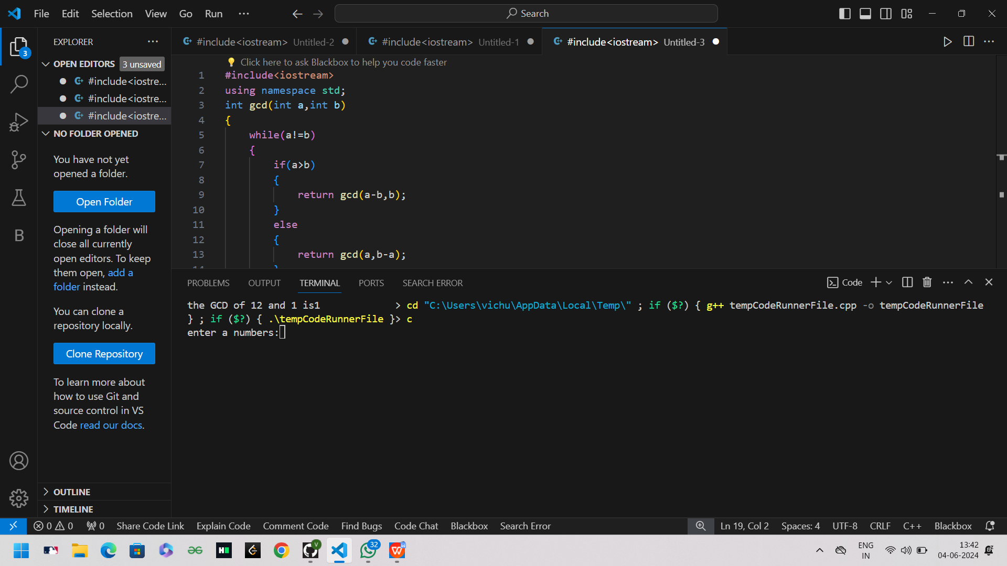

4.Write a program to get the largest element of an array.

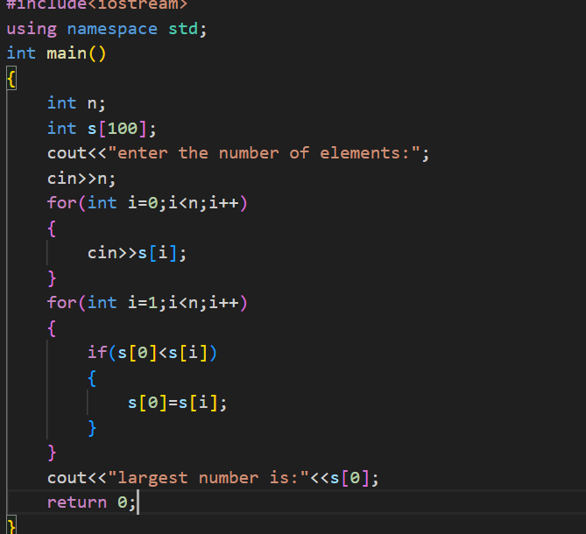

output

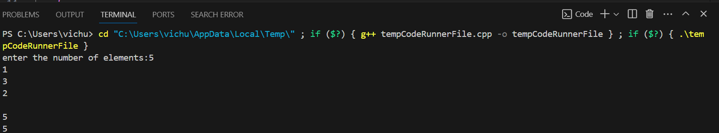

5.Write a program to find the Factorial of a number using recursion

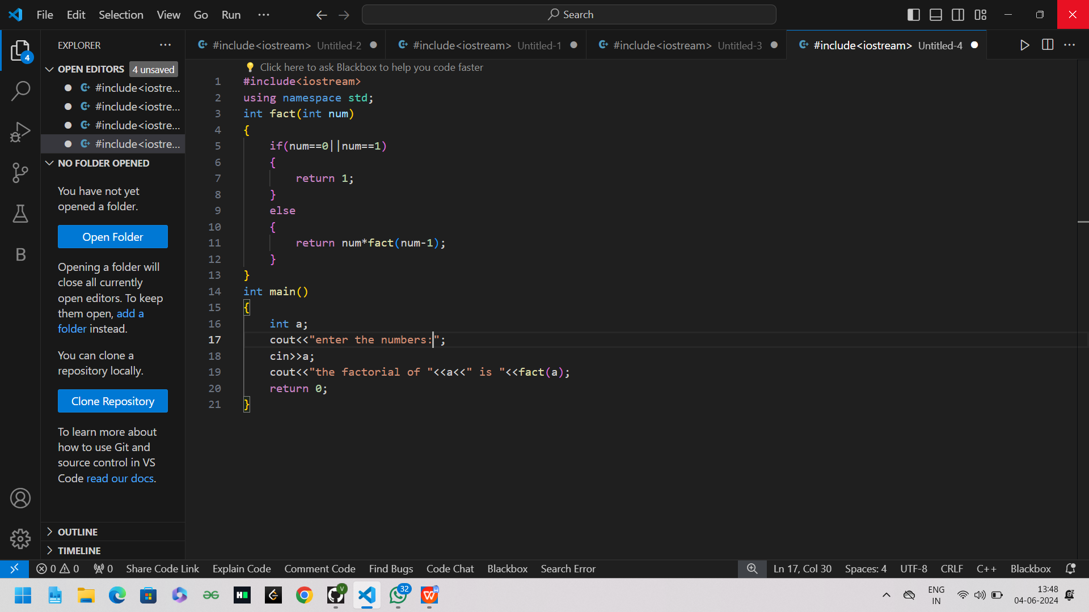

Output

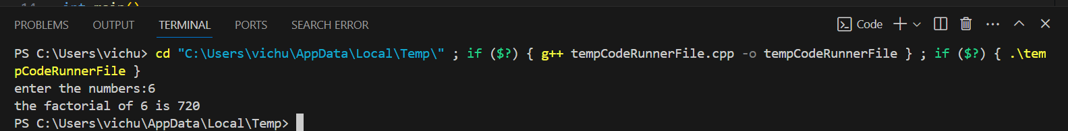

1. Write a program for to copy one string to another using recursion

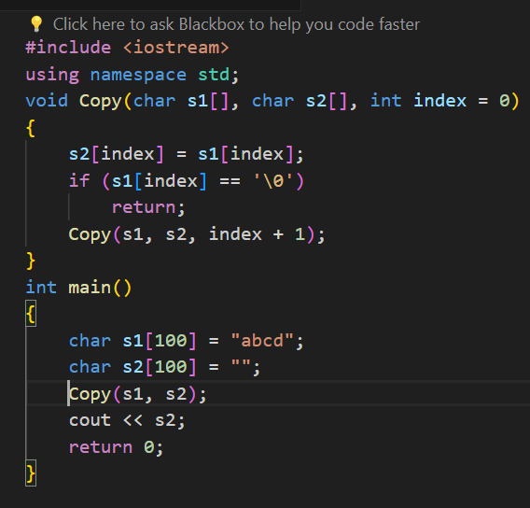

Output

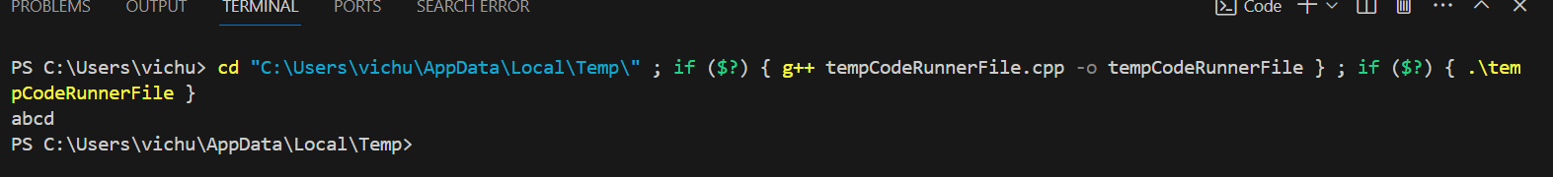

7.Write a program to print the reverse of a string using recursion

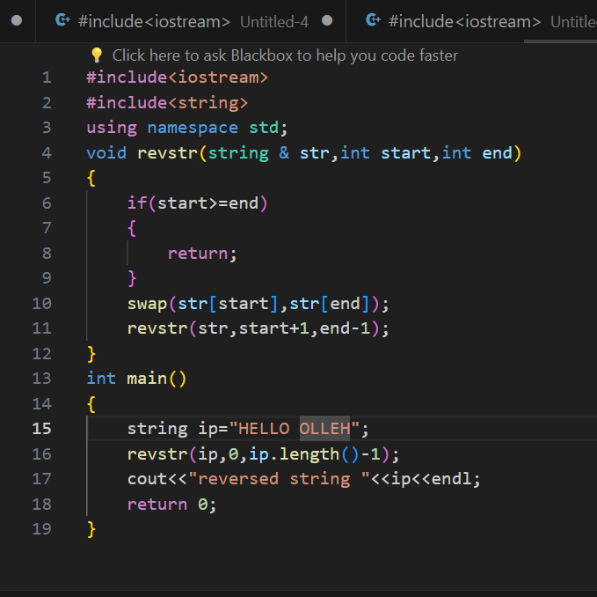

OUTPUT

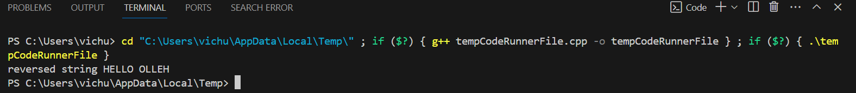

8.Write a program to generate all the prime numbers using recursion

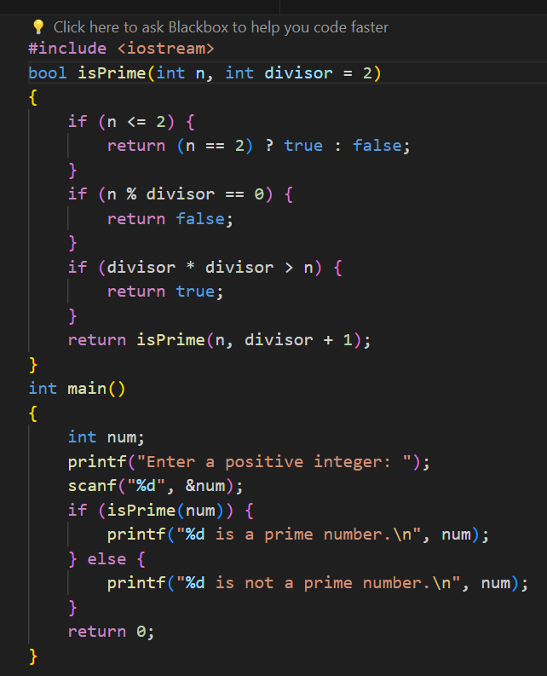

output

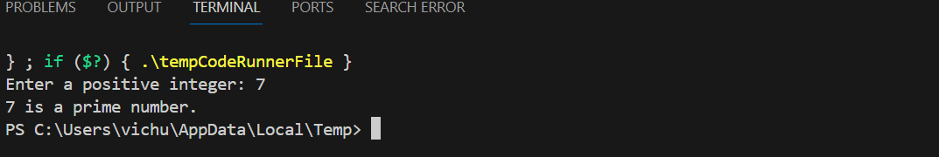

10.Write a program for to check whether a given String is Palindrome or not using recursion

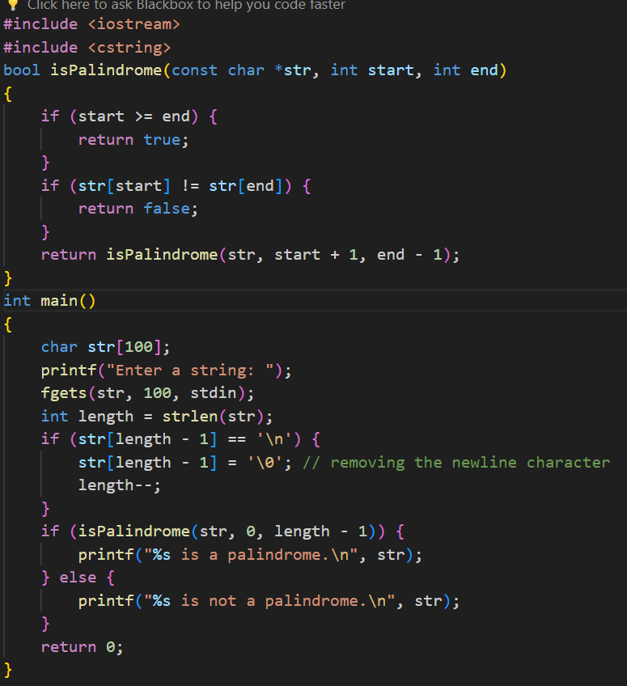

output

